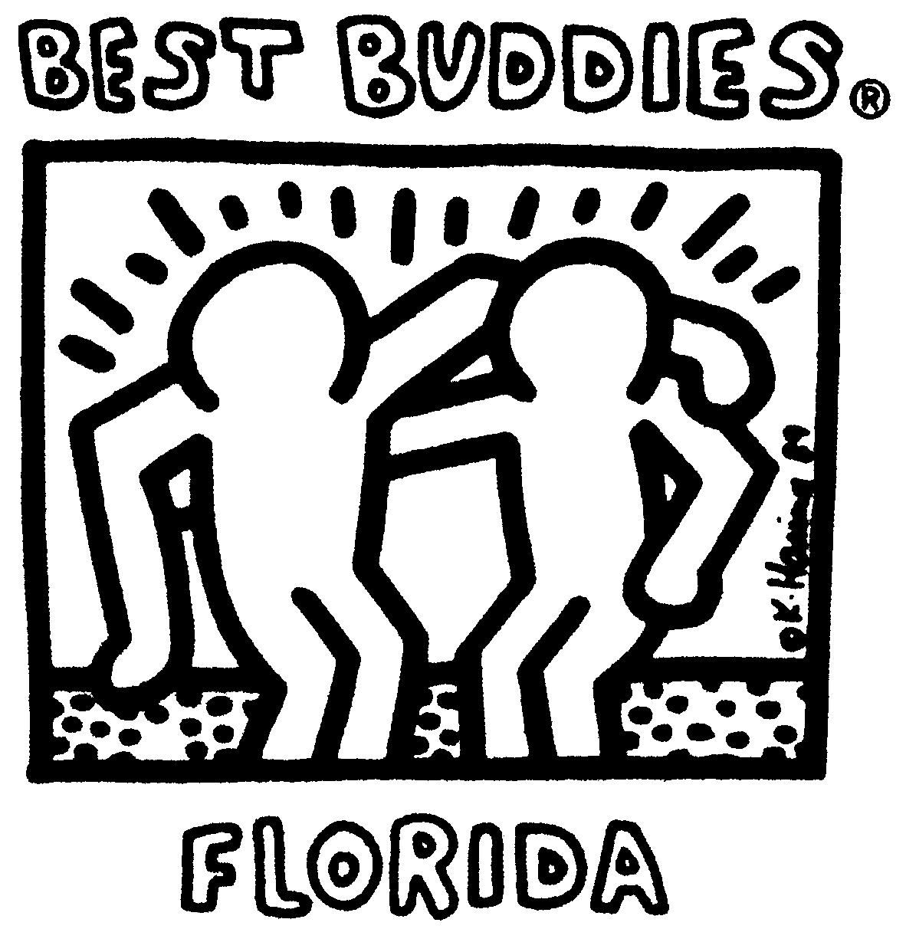
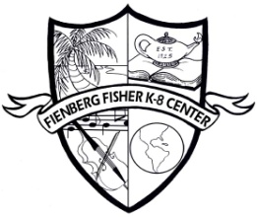

ROCK THE WORLD: Spread the Word to End the WORD CAMPAIGN
EVENT Summary and Schedule
Friday March 23, 2012

Mission: We will use the Spread the Word to End the WORD Campaign to make people aware of the damaging effects of the use of the r-word. Our mission is to replace the R-WORD (Retard) with RESPECT!

Best Buddies Day Staff Responsibilities

8:00- Breakfast

Set up- M. Khatmor, N. Tappert, I. Whalen, F. Torres

Buying Food- D. Klahr

9:00 Set up for Rock Ensemble

A.Paseiro

10:00-11:30 Children of the World Park/ Field

Field Games- W. Barron, R. Mendiola, D. Klahr, L. Barron

Face Painting- C. Merced, J. Stebbenne, L. Perez

Arts & Crafts- K. Bayon, N. Tappert, I. Whalen

Pledge Signing- F. Torres, M. Khatmor, Madeline (BB Rep.)

**Paseiro- Rock Ensemble will be performing.**(Mr. Paseiro will send email with participating students.)

**Ms. Heath to follow her students to each activity with Intern.

**Mr. Paseiro’s and Mr. Barron’s classes will be cancelled.

Media Center will be closed in the morning

Coverage:

Coach Hipo will cover Mr. Paseiro’s 4th period class. Thank you

Sandra Murphy will cover Ms. Barron’s 2nd period class. Thank you

Marcela Marcos will cover Ms. Barron’s 4th period class. Thank you

